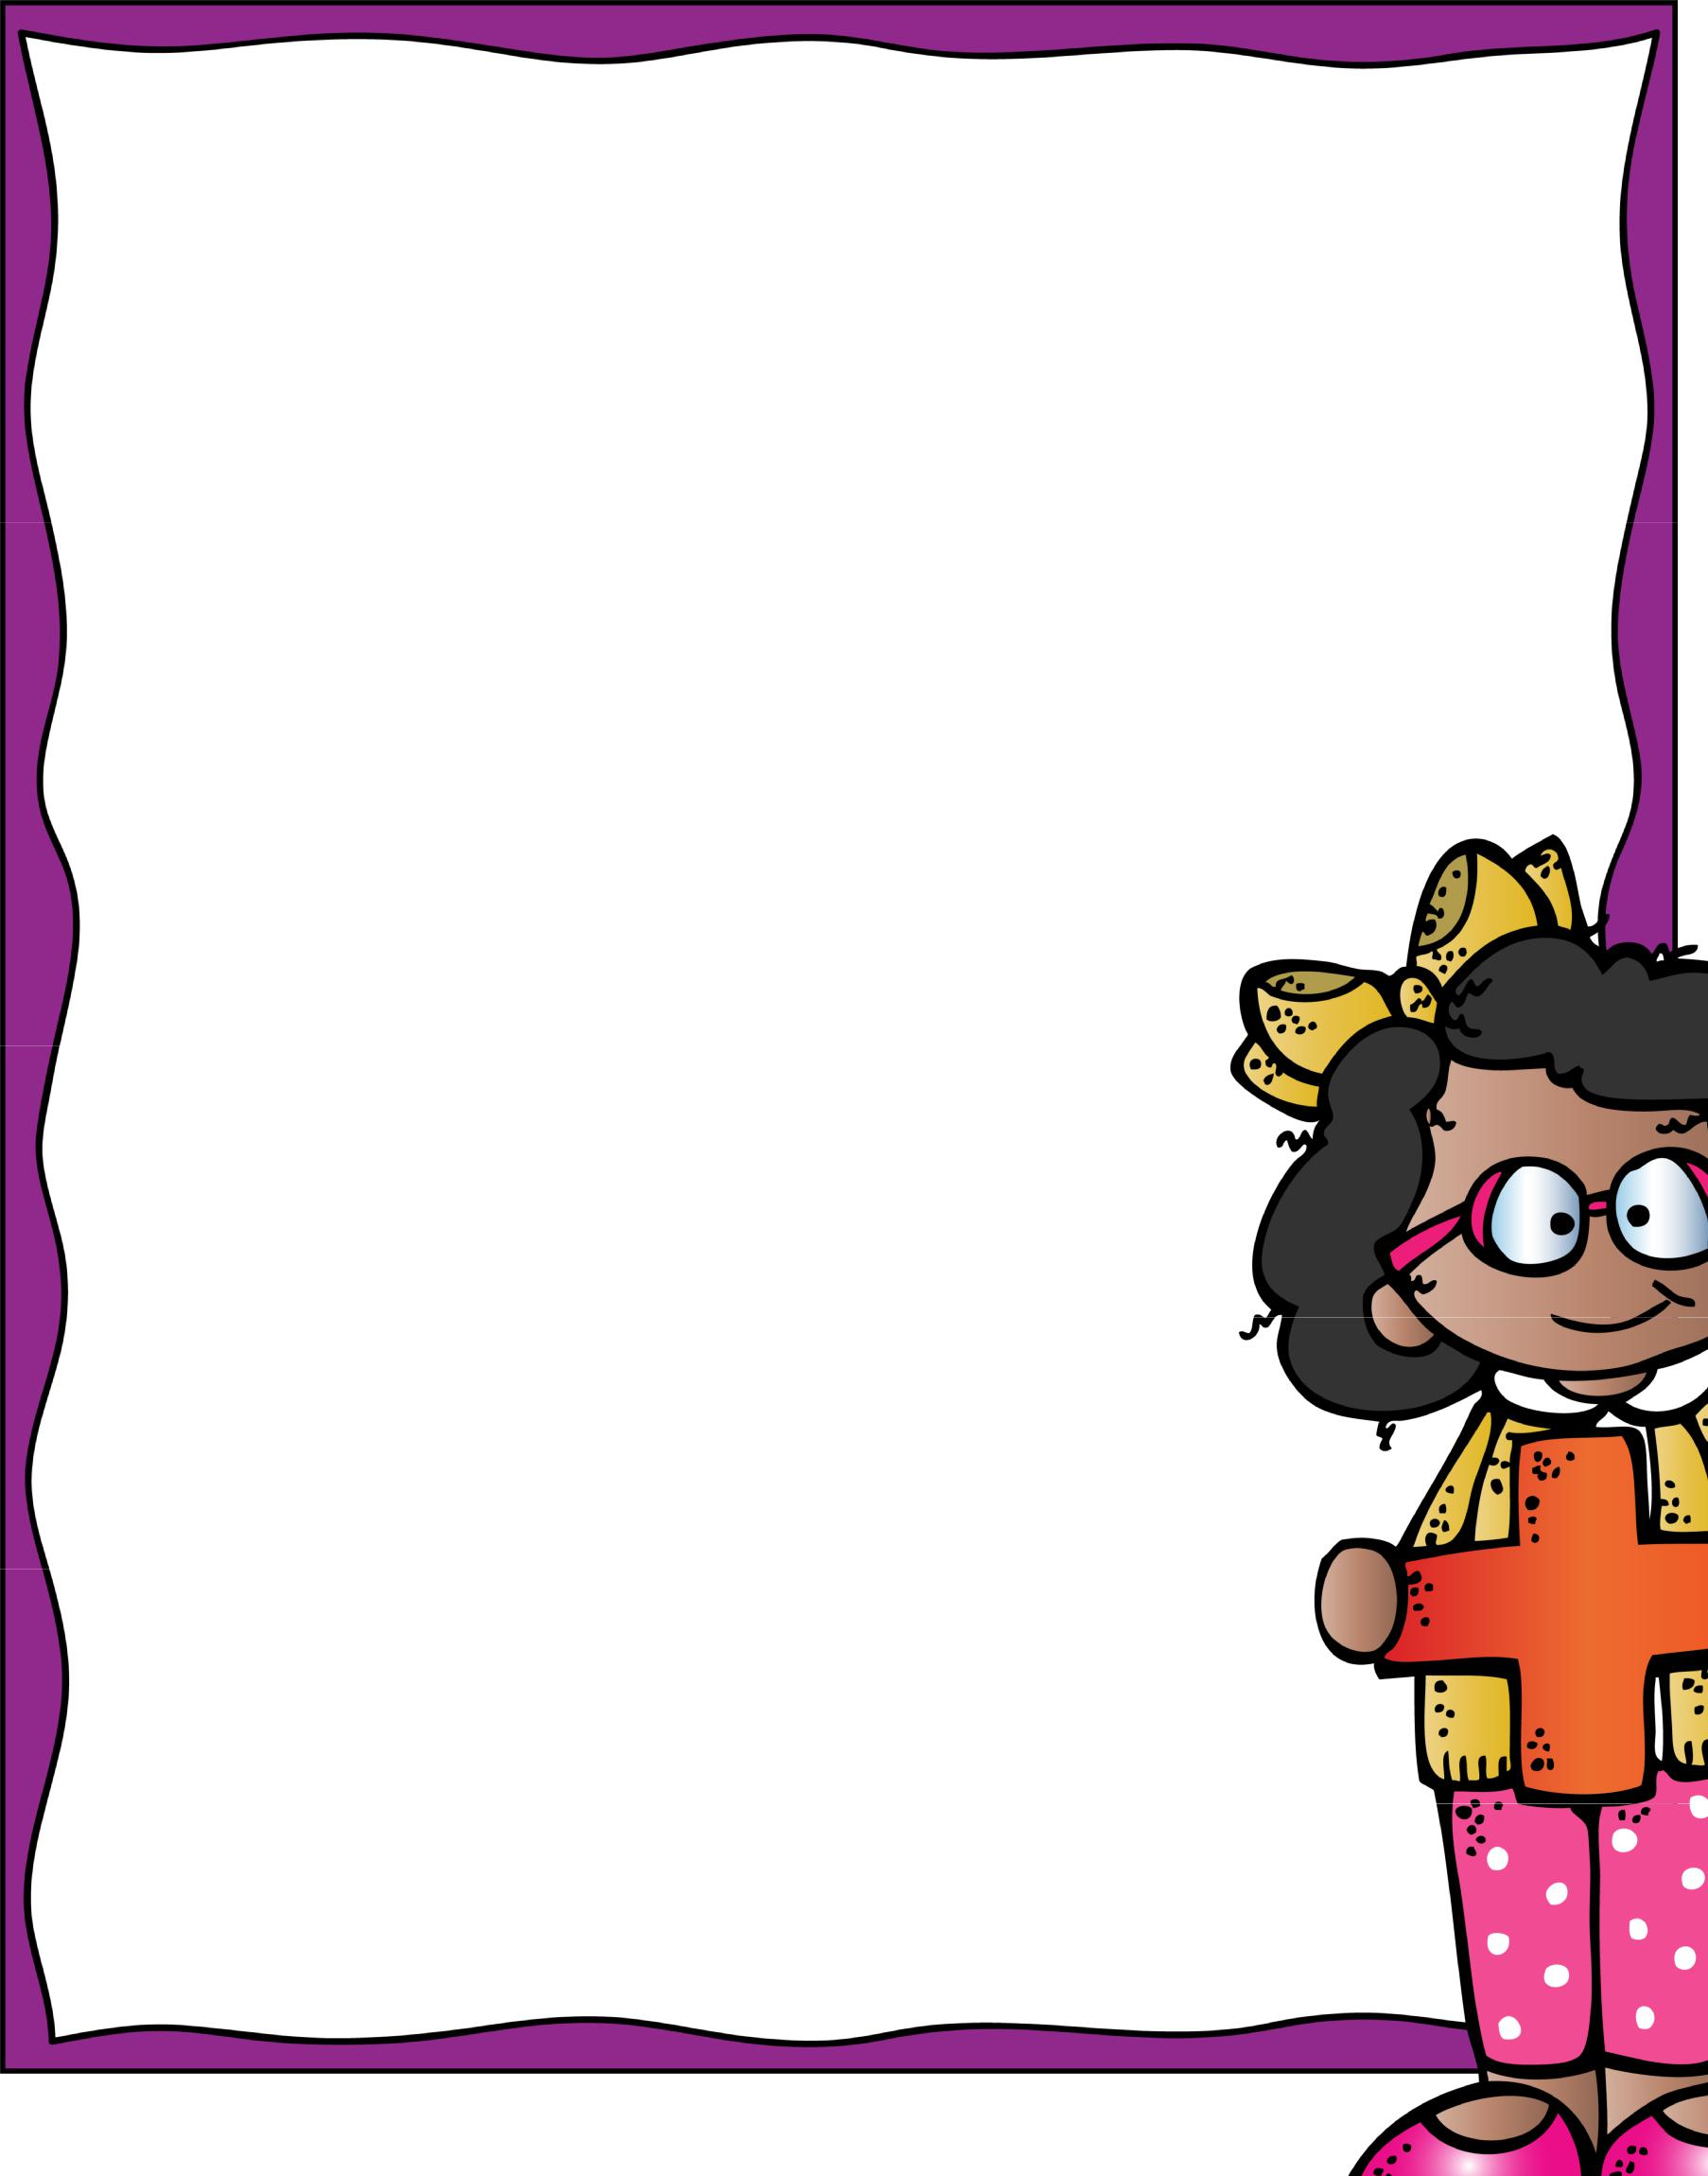
Addition and Subtraction within 1,000
Go Math!
Chapter 1

Vocab cards

OA.8, OA.9, NBT.1, NBT.2

©MookerDoodles2015

Addition and Subtraction within 1,000

After this subunit, students should be able to:

- Round numbers to the nearest 10 and 100

- Estimate sums or differences based on rounding

- Add digits in each place value correctly

- Subtract correctly without regrouping

- Subtract correctly with regrouping

Student friendly I Can statements

- I can round numbers to the nearest 10

- I can round numbers to the nearest 100

- I can estimate the sum or difference of two numbers

- I can add and subtract within 1,000

Vocabulary:

Pattern Commutative property of addition

Estimate Associative property of addition

Round Identity property of addition

Compatible Numbers

©MookerDoodles 2015

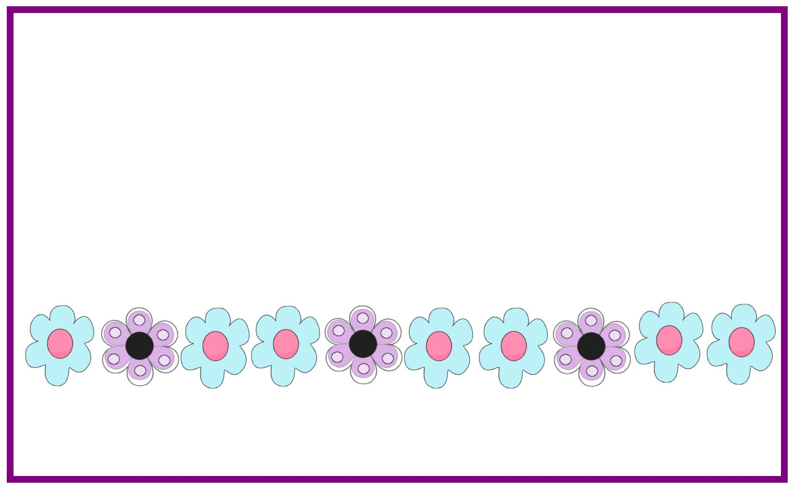
Pattern

An ordered set of numbers or objects in which the order helps you predict what will come next

Ex: 2, 4, 6, 8, 10, 12, 14, 16, 18, 20
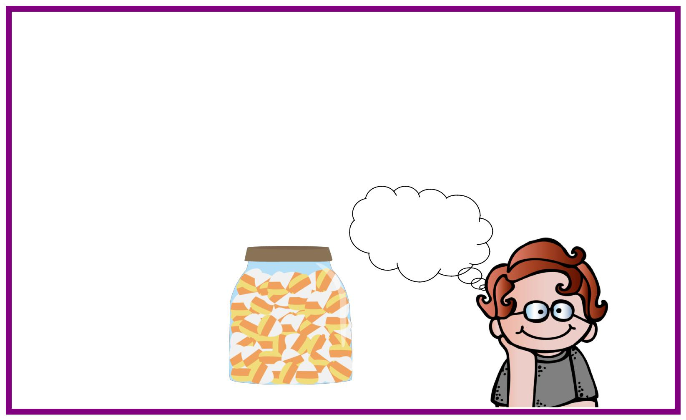

Estimate

A number close to an exact amount

Maybe there

are 25 or 30 in the jar!

Jar = 27

©MookerDoodles 2015

Round

To replace a number with another number that tells about how many or how much
889900

7880

Commutative Property of

Addition

You can add two or more numbers in any order and get the same sum
+= +
= =

©MookerDoodles 2015

Associative Property of

Addition

You can group addends in different ways and still get the same sums.
(5+3)+4 = (4+5)+3

(8) +4 = (9)+3

12 = 12
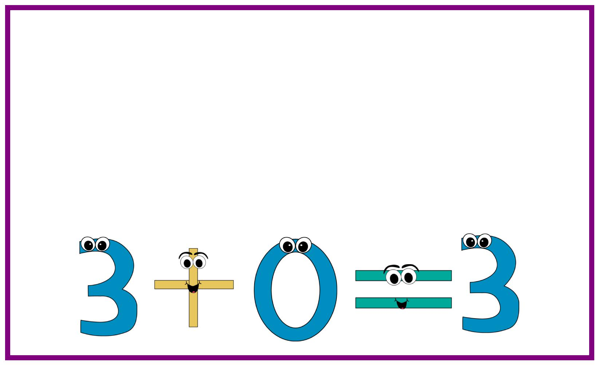

Identity Property of

Addition

When you add zero to any number, the result is that number

©MookerDoodles 2015

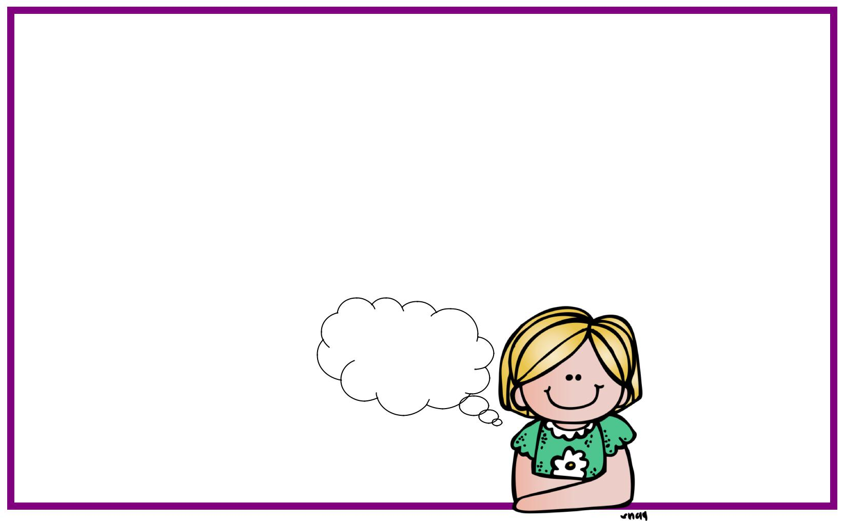
Compatible Numbers

Numbers that are easy to compute mentally
What is 27

close to?

25!
27...

